OMAGH INTEGRATED PRIMARY SCHOOL & NURSERY
72 Crevenagh Road. Omagh. Co.Tyrone BT79 0GW
Tel/Fax - 028 8224 2008 - Email: abradley561@c2kni.net

Principal
Mr Anthony Bradley. B.Ed., M.Sc., Adv. Dip. P.D. (ADHD)
Vice Principal
Mrs Siobhan Taggart. B.A. Hons., P.Q.H. (N.I.)

28th August 2018

Dear Parent/Guardian,

I trust you and your family had an enjoyable and restful summer break and are ‘gearing-up’ for the start of the new term. It is with great pleasure that I write to you from our new school which has undergone continuous work over the summer holidays to complete various areas both inside and outside of the school, and it’s looking even better than when you last saw it in June.

By necessity, several changes have had to be put in place for the new sight in relation to the smooth operation of the school and the health & safety of all users. We ask your cooperation and patience over the next few months and term as we all get used to our new surroundings and operational systems which will undoubtedly be ‘tweaked’ for improvement as time goes on. We will keep you fully informed of any adjustments to procedures as we progress throughout the school year but in the meantime I would ask you to note the following points:

- ENTERING & EXITING THE SCHOOL.

Entering and exiting the school is through the main gate on Crevenagh Road (which has now been widened to improve traffic flow at the roundabout). A ONE-WAY SYSTEM is in operation with traffic turning immediately left upon entering the school and proceeding either (a) to the main car park and exiting from there or (b) following the main road round to drop-off children at the outside entrances. Please DO NOT PARK IN THE DESIGNATED BUS PARKING BAYS or DISABLED SPACES (unless displaying a valid permit). PLEASE SEE SCHOOL PLAN OVERLEAF

- CREVENAGH ROAD.
The Crevenagh Road is currently CLOSED as ‘Gas to the West’ are laying pipes. The two main access roads to the school will therefore be the new link road off the Beragh Road from Omagh Hospital and Bankmore Road off the main A5 Dublin Road.
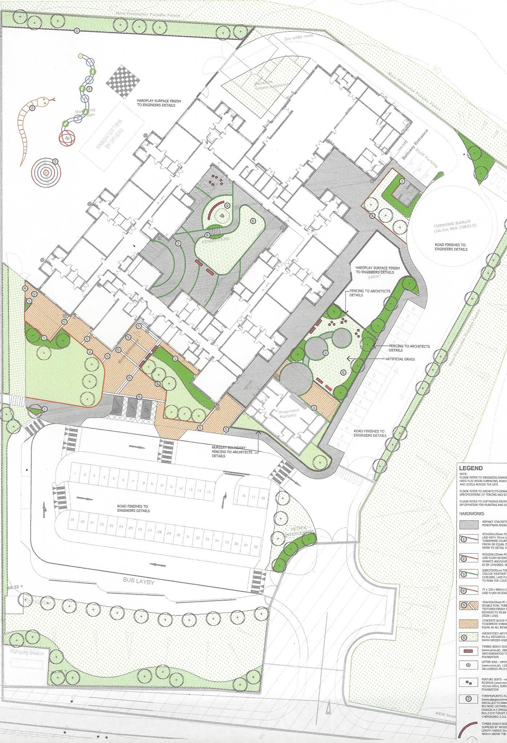
Y4-7 pupil entrance.
Staff Parking
Main Car Park
& Exit
EXIT
ENTRANCE
Nursery & Y1-3
Pupil entrance.
Main Entrance
FRIENDS pre-school entrance
Bus Drop-Off Bays

- NEW STARTING & FINISHING TIMES / PICK-UP
To try to alleviate possible congestion, the
NEW STARTING TIME is 8.45am
for all pupils from Monday 3rd September 2018.

Pupils using the Breakfast Club located in our new canteen may enter the school from 8.15am whilst all other pupils may enter the school at 8.30am and go straight to the assembly hall where they will be collected by their teachers at 8.40am.

Pupils arriving at, or after, 8.45am should go straight to their classroom via their external classroom door and not through the school. For security purposes, all external doors will close automatically at 9.00am and anyone wishing to enter after this time must do so through the main entrance (except for .

It is very likely that traffic will be a bit chaotic for the first few weeks of the new term as people get used to getting to/from our new school location at the earlier times and systems adapt to changing circumstances, so we will obviously be as accommodating as possible in relation to children getting to school at the new times. We ask for your patience and cooperation whilst we all get used to the new arrangements.

FINISHING TIMES ARE NOW EARLIER THAN BEFORE as follows:
Revised School Hours:
Nursery - 8.45am to 12.05pm
Year 1 & 2 – 8.45am to 1.45pm (see separate note for September Y1/2 pick-up arrangements)
Years 3 - Monday to Thursday 8.45am to 2.40pm & Friday 8.45am to 1.45pm
Year 4 to 7 – 8.45am to 2.45pm
- We appreciate the prompt collection of your children as it can be distressing for them if they are left waiting after their finishing time.
- Nursery children attending the Breakfast Club may arrive from 8.15am and where they will be supervised until 8.45am.

- SCHOOL MEALS & BREAKFAST CLUB
We are now in a position to offer delicious, freshly cooked meals daily, in our brand new canteen/kitchen, by two new staff members, Sandra Maxwell and Andrina Adams. Both have years of experience in cooking school meals and have planned varied and nutritious menus which we would encourage the children to avail of. They will also be operating the school’s ‘BREAKFAST CLUB’ from 8.15am each morning.

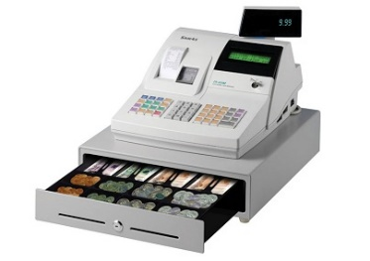
The biggest change in our school meal provision is the introduction of a TILL SYSTEM to pay for meals. Children will pay for their meal daily at a till in the canteen. It may be a good idea to put dinner money into a small purse or wallet for safekeeping (with child’s name written on it). Meals currently cost £2.60. Separate arrangements are in place for those entitled to free school meals.

EDUCATION AUTHORITY INSTRUMENTAL MUSIC TUITION

Parents whose children are to avail of EA’s instrumental music tuition will have to register with EA’s Music Department before the start of term, if they have not already done so (Tel: 82411411) and will be charged a fee. Our school is invoiced for the tutor costs which is to be paid in turn by the parents of pupils receiving lessons. This will be collected termly and further details will be sent to participating pupils shortly.

As we begin a new chapter in the history of Omagh Integrated Primary School & Nursery, in our brand new school, I wish to thank all of our current and past parents, staff, principals and governors for their support in ‘making the dream a reality’. I particularly acknowledge those founding parents who had the vision, foresight and bravery to look beyond the religious and political boundaries that existed at that difficult time of OIPS’s inception and thank them wholeheartedly on behalf of us all for their courage. Without them, we would not be where we are today.

I wish everyone a happy and successful school year.

___________________
A Bradley
Principal

