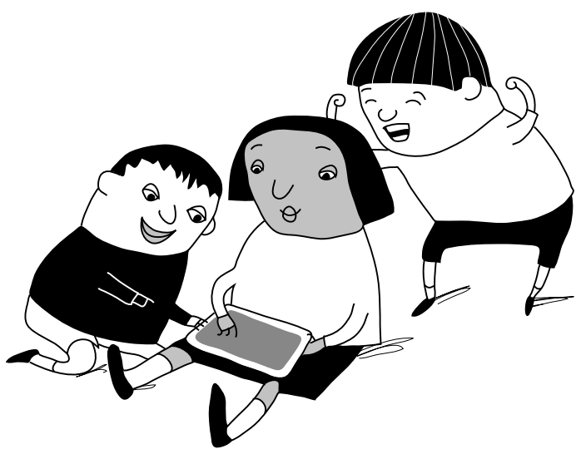
Are you a young person who's being bullied/ experiencing bullying behaviour? Or maybe you're witnessing others being bullied? Either way there are ways around it. Here are our anti-bullying tips for you.
- It doesn’t matter what colour hair you have; what trainers you are wearing; how you speak; how you walk; how you talk – it is not your fault if you get bullied. We are all different in some way and that’s what makes us amazing.
- Whether you are a boy or a girl, old or young, big or small – bullying makes you feel rubbish and it’s okay to be upset about it. The important thing is that you tell someone about it.
- If you feel you can, talk to a teacher you trust, your parents, brother or sister or somebody at home. If you don’t want to do that you can always call Childline 0800 11 11 or visit www.childline.org.uk.
- Keep a record of what happened, when it happened, and who was involved. If the bullying is online, keep the evidence – save or copy any photos, videos, texts, screenshot, emails or posts.
- It can be tempting if you are being bullied to retaliate – for example to send a horrible message back to someone; to try and embarrass and hurt the other person, or to fight back. This is not a good idea– you might end up being seen as the trouble maker or get yourself even more hurt.
- Think about other ways you can respond to bullying. For example, practise saying: "I don’t like it when you say that/do that – please stop." Think about other people who can help you if you are being bullied – this could be other classmates, or a teacher.
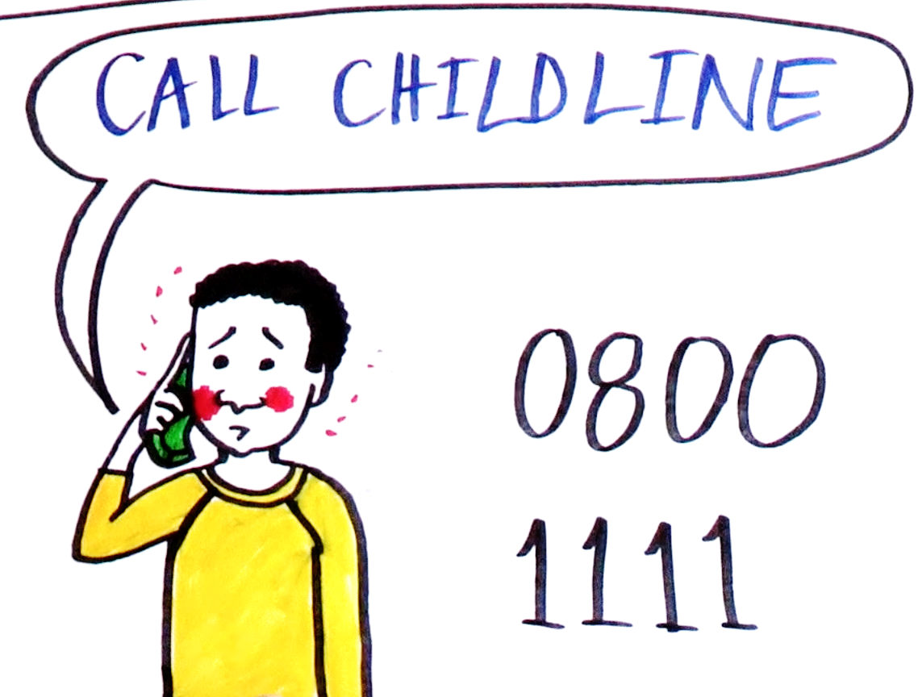
- Only hang out with people who make you feel good about yourself. If someone constantly puts you down they are not a real friend and not worth your time.
- Be kind to yourself, and do things that make you feel good, relax and make new friends. You might play an instrument; write lyrics; draw cartoons; dance; act or join a sports club. This is your life so make sure it’s the best life possible – don’t let anyone bring you down.
- Remember to be kind to other people! Just because someone is different to you and your friends – that doesn’t mean you are better than them or have a right to make them feel bad. If you mess up, say sorry. You don’t have to be friends with everyone – but you should always show respect, make it clear that you don’t like it when people bully others, and stick up for people who are having a hard time. If you see someone being bullied try to help, by encouraging them to tell or by reporting what you have seen to an adult you trust. Everyone has a role to play in stopping bullying.

